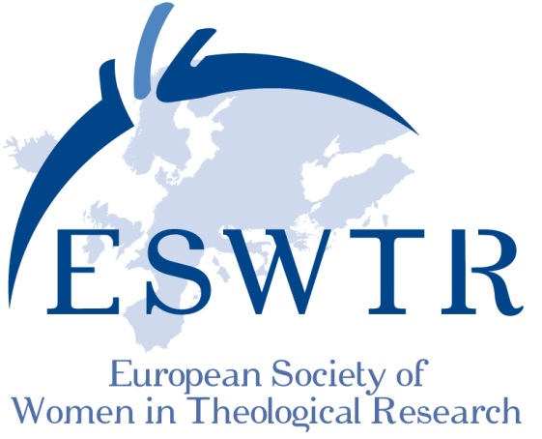
TRANSLATION - TRANSGRESSION - TRANSFORMATION
International Meeting of the ESWTR August, 23 – 26 2017, Vienna, Kardinal-König-Haus
Preliminary program (July 2016)
Opening address: Wednesday August 23, 7pm
Regina Polak (Pastoral Theology/ University of Vienna):
Dreams and Border Crossing Realities and Experiences of Migrating Women
Thursday, August 24 2017 Crossing Interreligious Borders
09.00-10.00 | Judith Gruber (Intercultural Theology / Loyola University)  Theology after the Cultural Turn
10.00-11.00 | Catherine Cornille (Boston)  Theology of Interreligious Dialogue
11.00-11.30 | Pause /Break
11.30-13.00 | Subject groups (call for papers)
13.00-15.00 | Lunch break  3 Parallel Panel sessions with each time two panel members in dialogue
15.00-16.30 | 30 minutes per panel member with concluding discussion with the audience
1. Jewish-Christian Dialogue
- Birgit Klein (Jewish Studies, Hochschule für Jüdische Studien, Heidelberg)
- Irmtraud Fischer, Edith Petschnigg (Old Testament, University of Graz)

2. Jewish-Muslim Dialogue
- Amina Nawaz (Islamic Theology, University of Tuebingen)
- Merav Rosenfeld-Hadad (University of Cambridge)

3. Christian-Muslim Dialogue
- Zilka Spahić-Šiljak (Sarajevo, Bosnien -Herzegowina)
- Anja Middelbeck-Varwick (Systematic Theology, Free University of Berlin)
18.30 | Dinner
20.00 | Encounter with "Sara, Hagar and Magdalena" from the afternoon sessions
Friday, August 25 2017 Crossing Biblical Borders
09.00-10.00 | Madhavi Nevader (St. Andrews University/ Scotland)  Transformation of Deities in Ancient Near Eastern and Biblical Studies
10.00-11.00 | Hanna Tervanotko (University of Helsinki)  The Transformation of Miriam
11.00-11.30 | Break
11.30-13.00 | Parallel Sessions with each time two panelists in Dialogue  - Social and religious changes in biblical studies (Old Testament)  Mercedes Navarro Puerto (Spain)  Carmen Bernabé-Ubieta (Universidad de Deusdo, Spain)  - Social and religious changes in biblical studies (New Testament)  Silke Petersen (University of Hamburg)  Marlis Gielen (University of Salzburg)
13.00-14.30 | Lunchbreak with time for meetings
14.30-16.30 | ESWTR General Assembly
16.30 | Cultural and social activities

Saturday, August 26 2017 Crossing Borders in Ethics
09.00-10.00 | Marta López Alonso (Madrid)  Care as Basic Principle in Bio-ethics
10.00-11.00 | Valeria Ferrari-Schiefer (Fachhochschule Gesundheit und Soziale Arbeit, Switzerland)  Considering the End of Life from the Perspective of Care-ethics

11.00-11.30 | Break
11.30-13.00 | Parallel sessions with each time two panel members in dialogue  1. Borders in Bio-ethics  - Angelika Walser (University of Salzburg, Theological Ethics): Experiencing the Borders and Demarcation of Borders as Basic Themes of a Theological Ethics?  - Fatma Aydinli (Universität Frankfurt am Main, Ethik):  Asking Questions at the End of Life  2. Transformation in Bodies  - C.A.M. van den Berg (University of Utrecht):  Transformation in Bodies  - Gertraud Ladner (University of Innsbruck):  Transformation in Bodies
13.00-15.00 | Lunch break
15.00-16.30 | Subject groups (call for papers)
ab 16.30 | Ritual conclusion, dinner and party
Sunday, August 27 2017 departure
Times reserved for individual group meetings:
Wednesday, 23 August at 5 pm: ESWTR Contact Women
Thursday 24 August at 2 pm: preparatory work for the AGM
Thursday 24 August at 5 pm: meetings in country-groups

